**" Sentiment Analysis on Movie Reviews"**

**Geo-Tagged photos:**

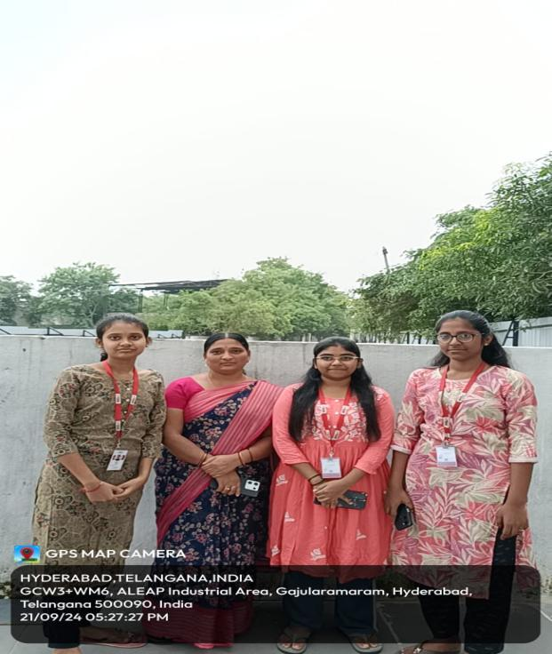 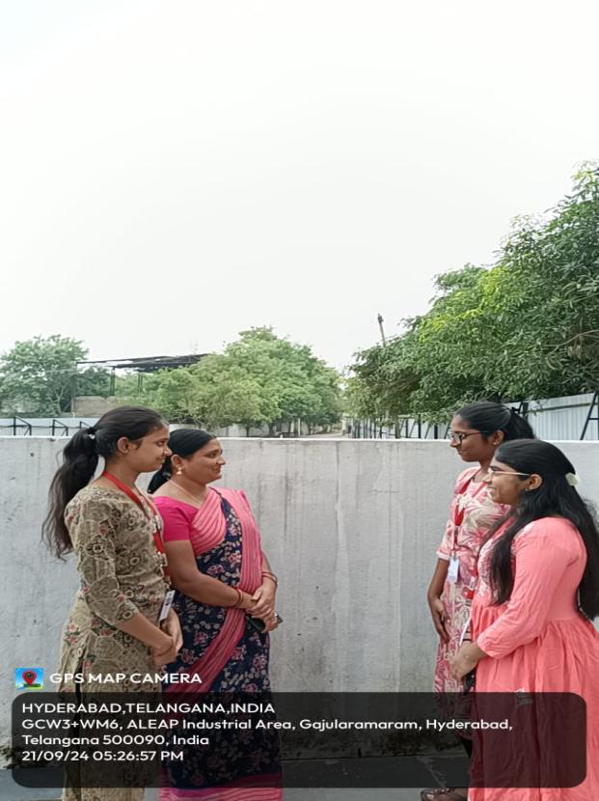

B Tejaswini - 2320040011

S Raveena-2320040043

P Srujana - 2320040053